**Session 8 – Kubernetes Operations Lab**

**Clean up old clusters**

Delete the existing cluster if it exists

% kind delete cluster --name tamlab

**Create a Kubernetes v1.20.2 cluster with KIND**

% kind create cluster --name tamlab --config kind-config.yaml --image kindest/node:v1.20.2

You should get something similar to the following output:

Creating cluster "tamlab" ...

✓ Ensuring node image (kindest/node:v1.20.2) 🖼



⢄⡱ Preparing nodes 📦 📦 📦

✓ Preparing nodes 📦 📦 📦

✓ Writing configuration 📜

✓ Starting control-plane 🕹️

✓ Installing CNI 🔌

✓ Installing StorageClass 💾

✓ Joining worker nodes 🚜

Next, view the available clusters

% kind get clusters

* You should see tamlab as one of the clusters

**Install and open Octant to view on-going deployments**

Octant website: https://octant.dev/

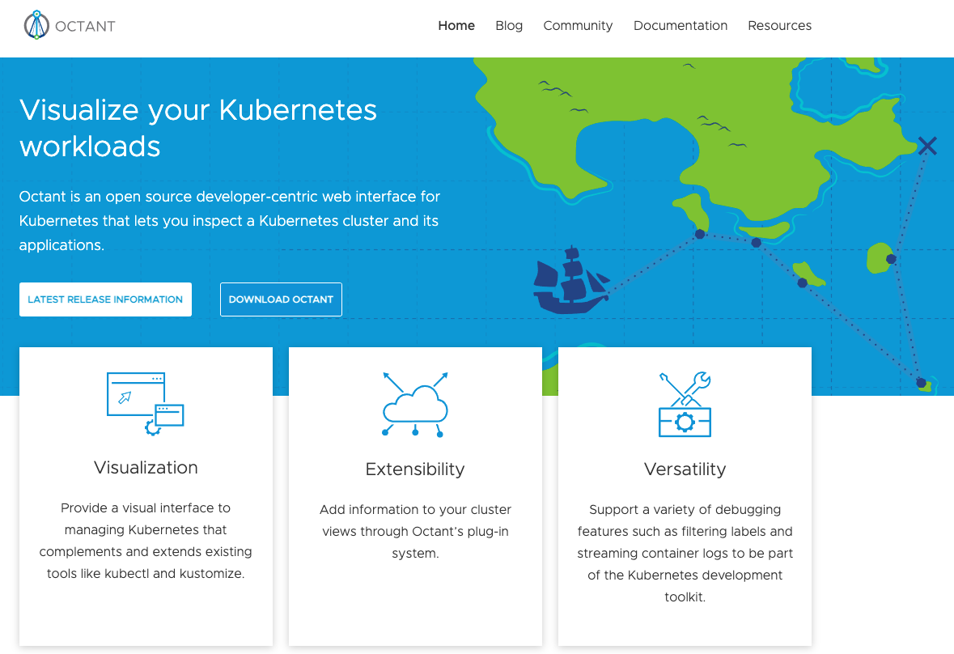

Install octant on macOS

Open a command shell

% Brew install octant

% octant

* This should open a browser window

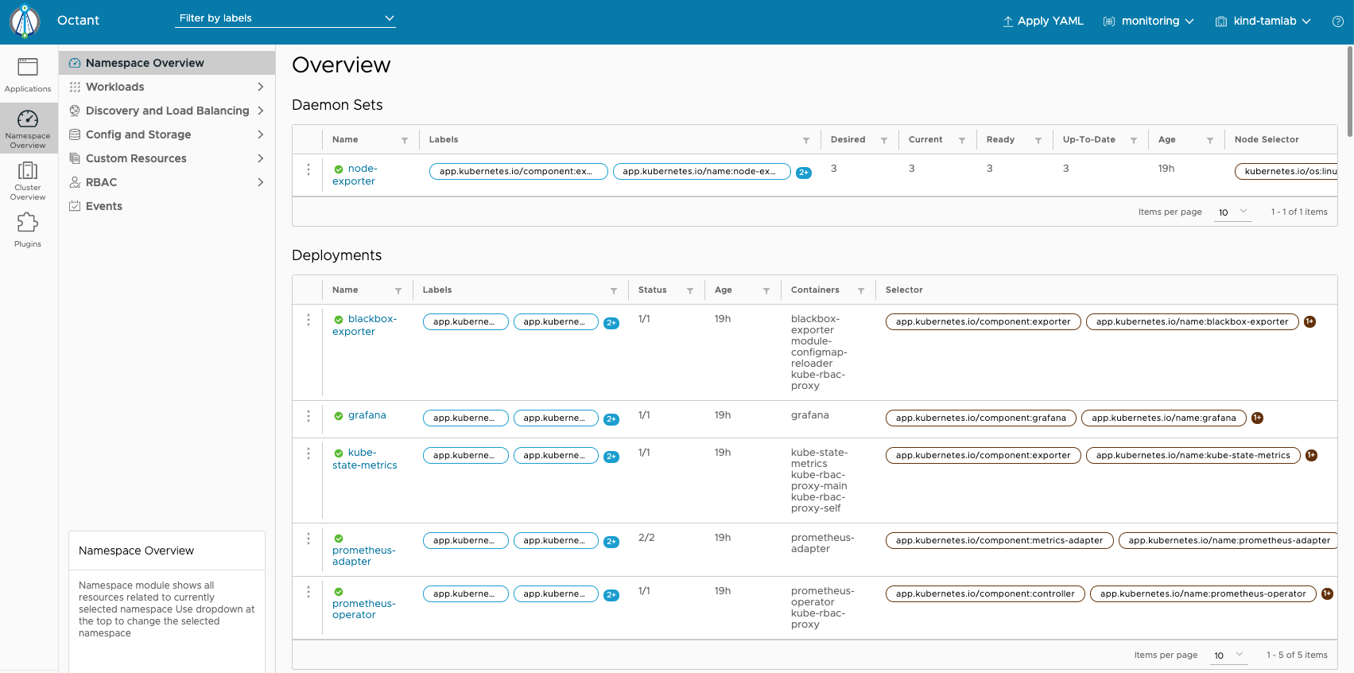

**Logging with EFK (ElasticSearch, Fluentd, Kibana)**



Change directory into the one containing session8-kubernetes-operations

Let’s deploy the logging namespace in the tamlab cluster. When you apply the namespace.yaml file, kubernetes creates the “logging” namespace

% cd logging

% kubectl apply -f namespace.yaml

% kubectl get namespaces

* You should see “logging” as one of the available namespaces

In Octant, pull down the namespace menu and select “logging”

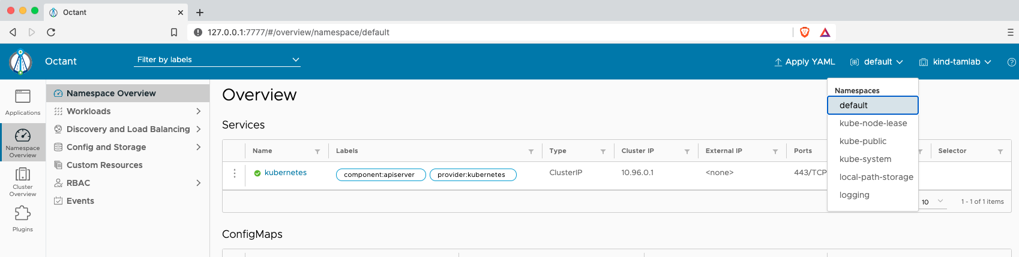



**Deploy Elasticsearch**

Elasticsearch website: https://www.elastic.co/elasticsearch/

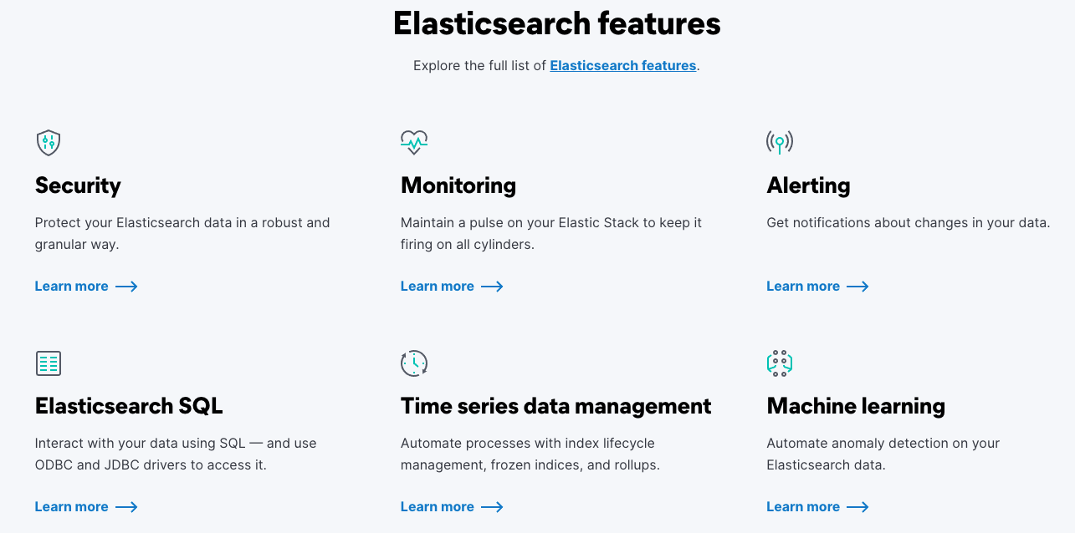

Review Kubernetes concepts in elasticsearch.yaml

% kubectl apply -f elasticsearch.yaml

#wait for elasticsearch statefulset to come up - this will take several minutes. Here’s a refresher on stateful sets from session 4:



% kubectl -n logging get all,pv,pvc

% kubectl -n logging describe pod/es-cluster-0

In Octant, you can also watch the pods, stateful sets and service being created:

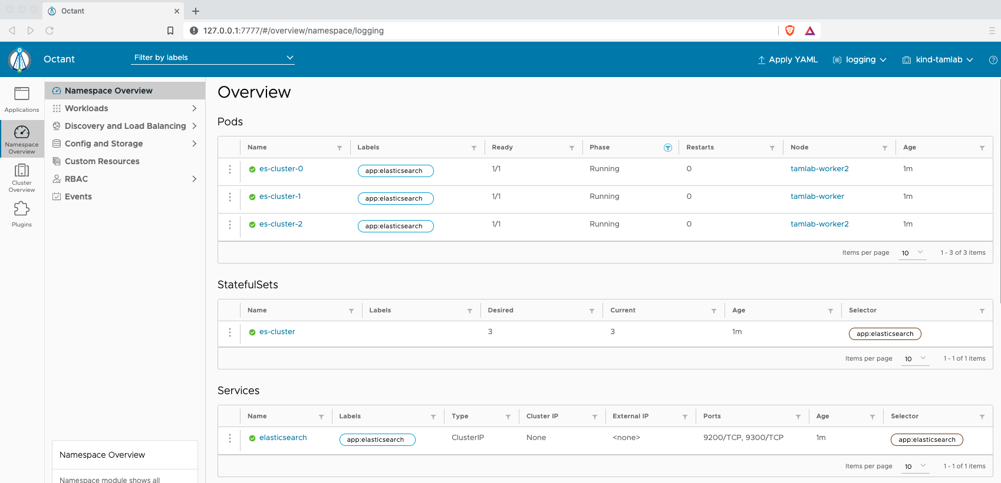



Also, in octant, scroll down and you can see PVC’s and the events:

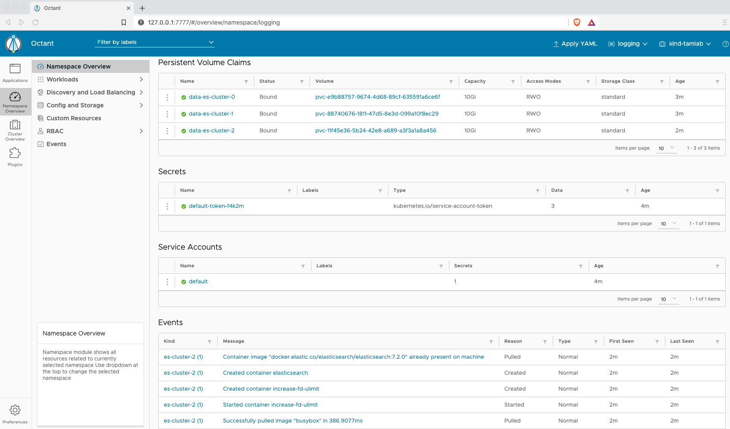

**Deploy Kibana**

Kibana website: https://www.elastic.co/kibana

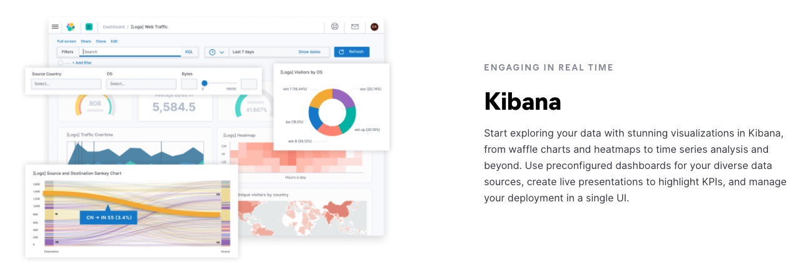

Let’s review a Kubernetes concept in kibana.yaml.

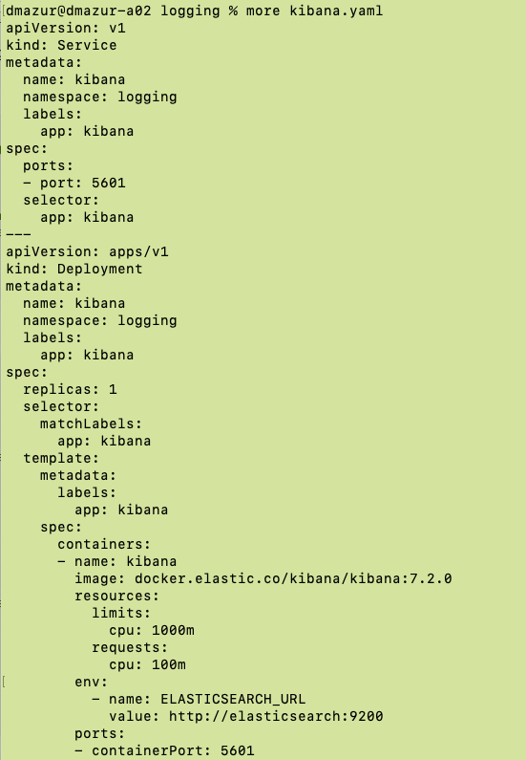

Note the resource limits for the container. Here’s a refresher on resource limits from Session 5:



Now deploy the kibana application:

% kubectl apply -f kibana.yaml

**Deploy Fluentd**

Fluentd website: <https://docs.fluentd.org/container-deployment/kubernetes>

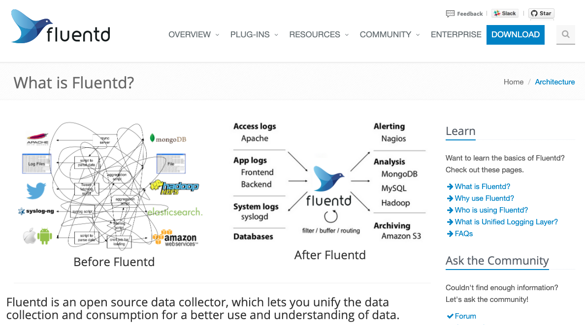

Review Kubernetes concepts in fluentd.yaml. Fluentd takes advantage of Daemonsets. An instance of fluentd will run on every node in the cluster to collect the log files. Also, note the cluster roles and cluster role bindings in the fluentd.yaml file.



Deploy the fluentd application:

% kubectl apply -f fluentd.yaml

**Access kibana**

Open a separate terminal window

List the pods in the logging namespace:

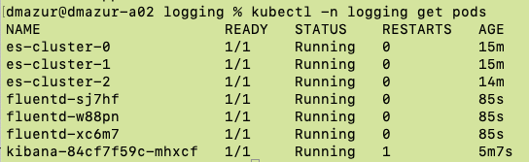



% kubectl -n logging port-forward pod/kibana-<suffix> 5601:5601



open browser to http://localhost:5601

follow prompts to create index pattern of "logstash-*"

view log files

**Generate some logs files and view in Kibana**

**https://www.digitalocean.com/community/tutorials/how-to-set-up-an-elasticsearch-fluentd-and-kibana-efk-logging-stack-on-kubernetes**

**Deploy cAdvisor**

**cAdvisor website:** https://github.com/google/cadvisor

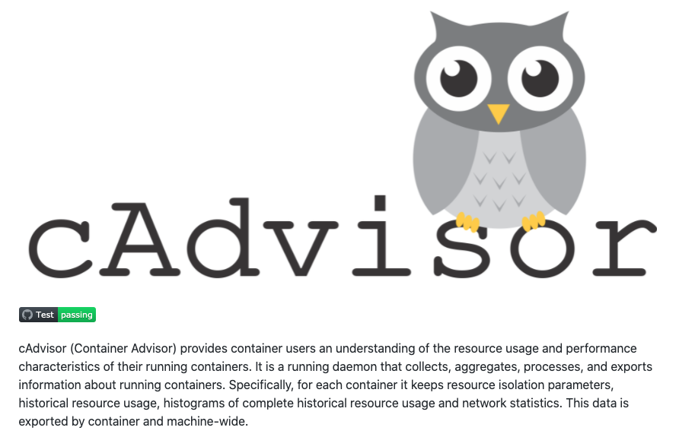

% cd ..

% kubectl apply -f cadvisor/cadvisor.yaml

open browser to: <http://localhost:31194/containers/>

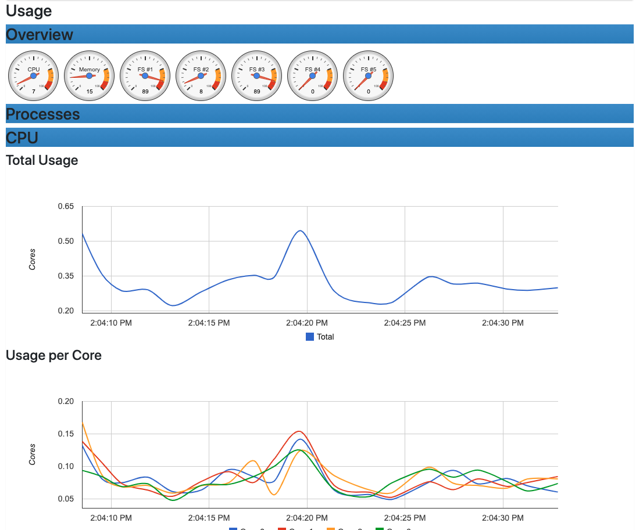

**Install the Prometheus operator and Grafana**

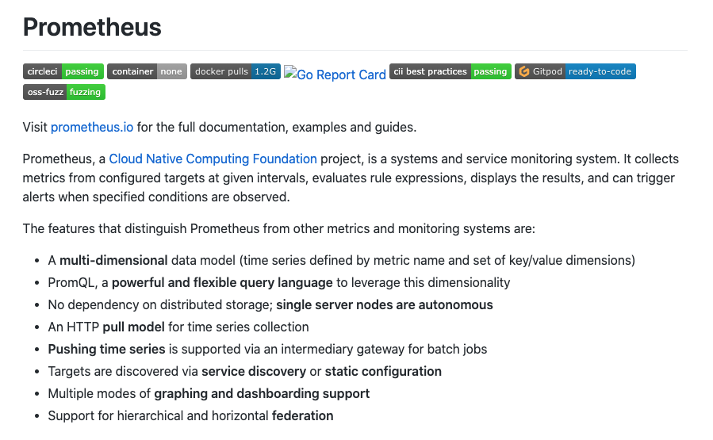

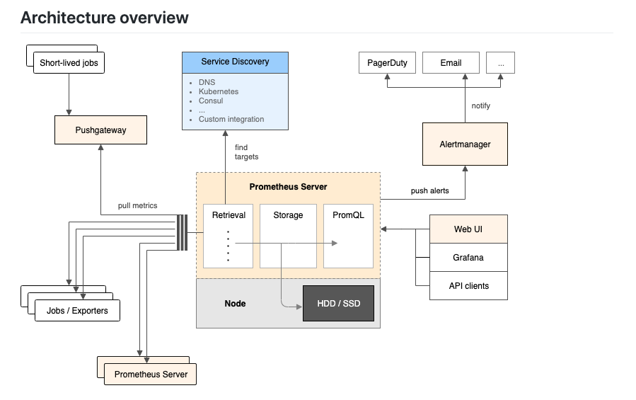

#git clone the kube-prometheus code locally

% git clone https://github.com/prometheus-operator/kube-prometheus.git

% cd kube-prometheus

#setup namespace and CRDs

% kubectl create -f manifests/setup

You should see something similar to:

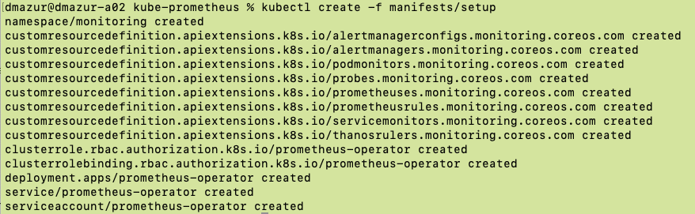

**Review Operators from last session**

* Prometheus and grafana use operators to install and configure the complex application. Here’s a review of operators.



#deploy prometheus operator

% kubectl create -f manifests

% kubectl -n monitoring get all,pv,pvc

In Octant, first select the “monitoring” namespace which was created via the operator. You can also watch the deployments, daemonsets, pods, replicasets, etc being created:

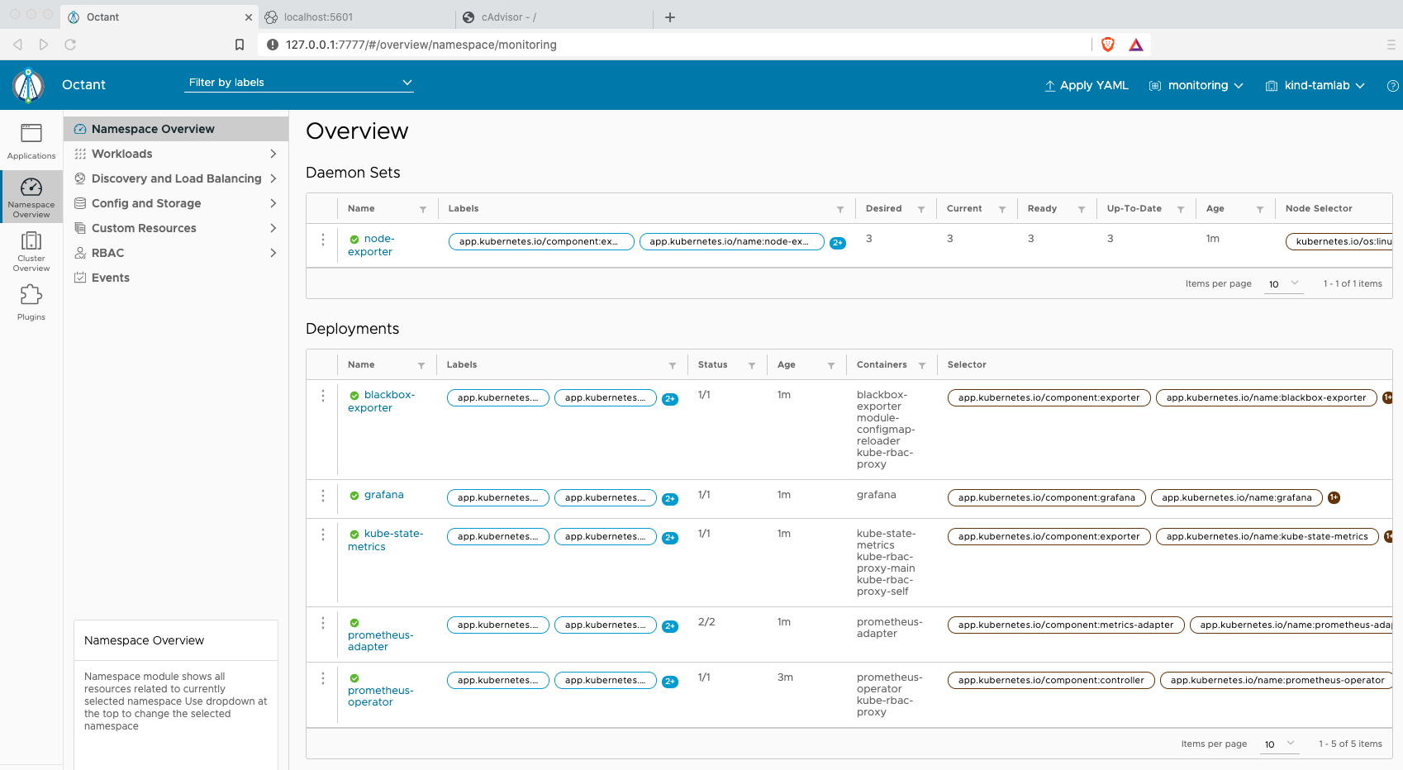

Review components installed

* AlertManager
* BlackBox

#explore Prometheus

# open a new terminal window

% kubectl -n monitoring get pods

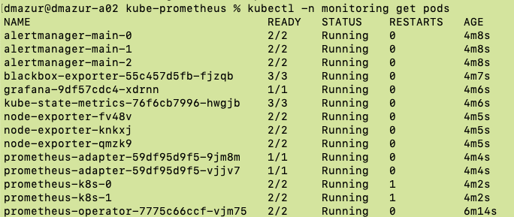



% kubectl -n monitoring port-forward pod/prometheus-k8s-0 9090

open browser to <http://localhost:9090>

Look at alerts:

* Select “Alert” then “Watchdog” pulldown:

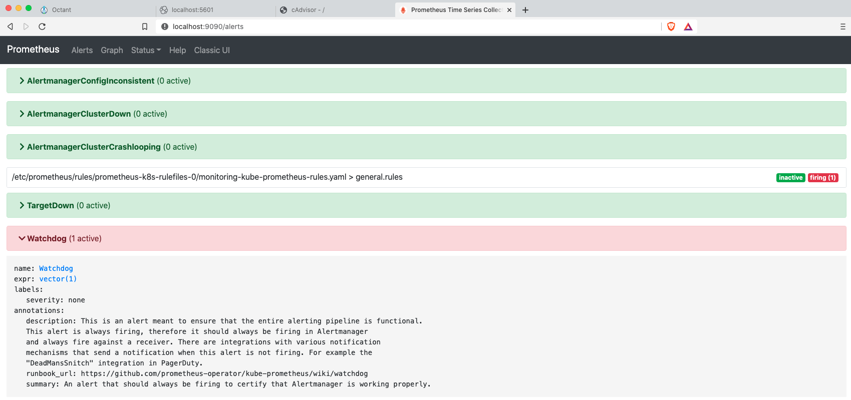



Next, look at “Graphs”

* Select the “Graph” tab then the “Metrics Explorer”

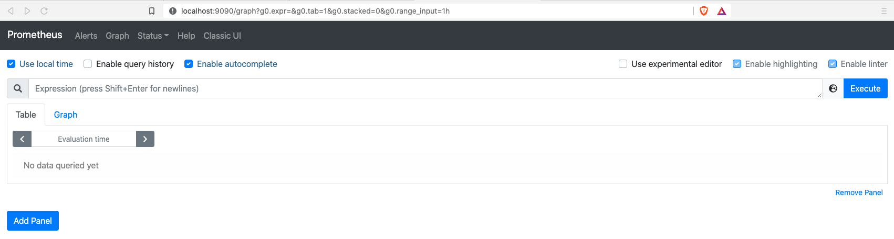



You should see a list of metrics.

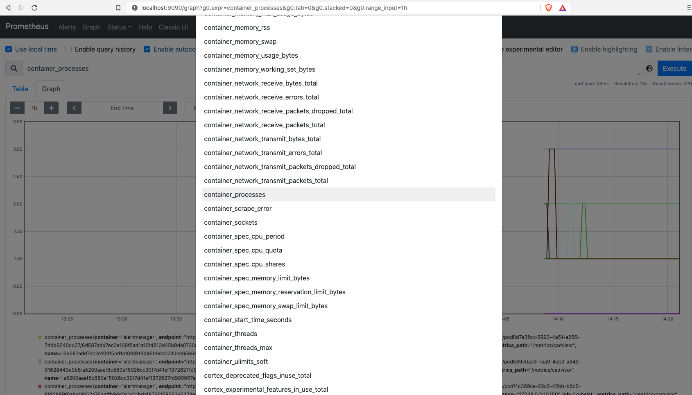



Select the “container_processes” menu item

Then select “Execute” and the “Graph” tab:

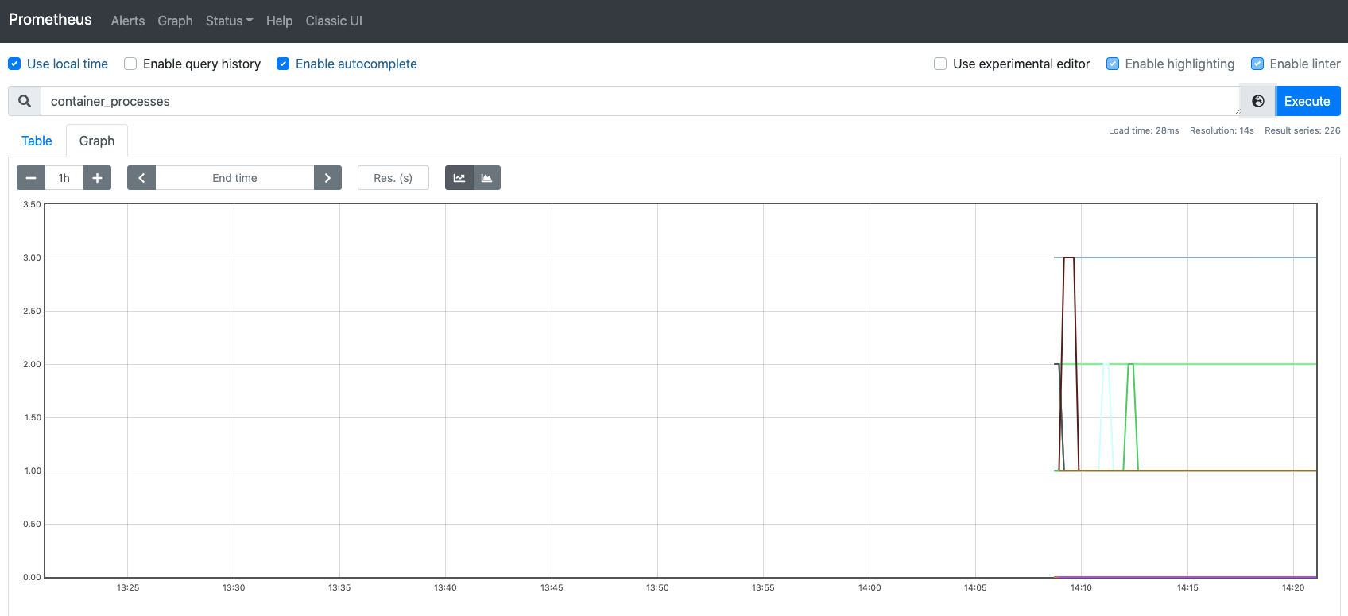



You should see data generated

**Explore Grafana**

#open a new terminal window

% kubectl -n monitoring get pods

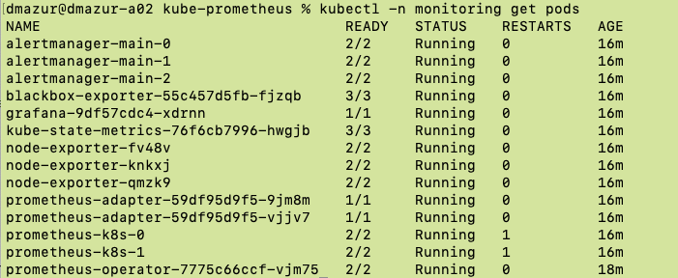

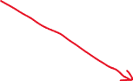

% kubectl -n monitoring port-forward pod/grafana-<suffix> 3000

open browser to <http://localhost:3000>

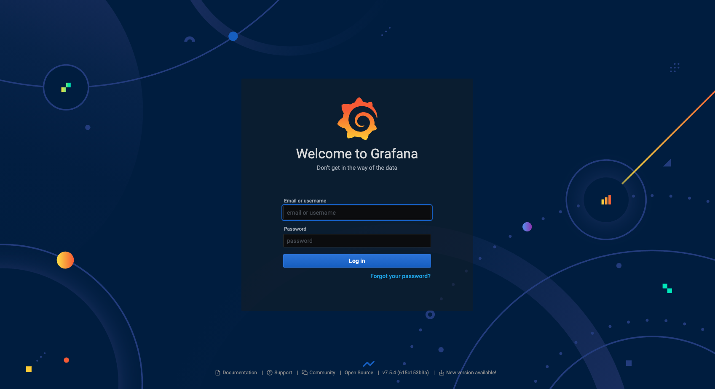

Login to Grafana with admin and password admin

>> you are then forced to create a new pwd (I used VMware1!)

Import a new dashboard

* Select the “+” sign and then the “Import” menu item:

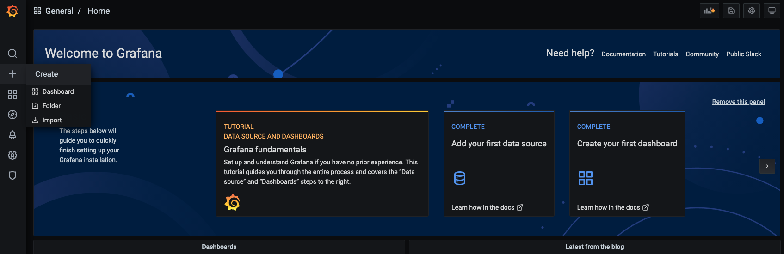



Enter “6336” under “Import via Grafana.com, then select “Load”. These are public dashboards you can use:

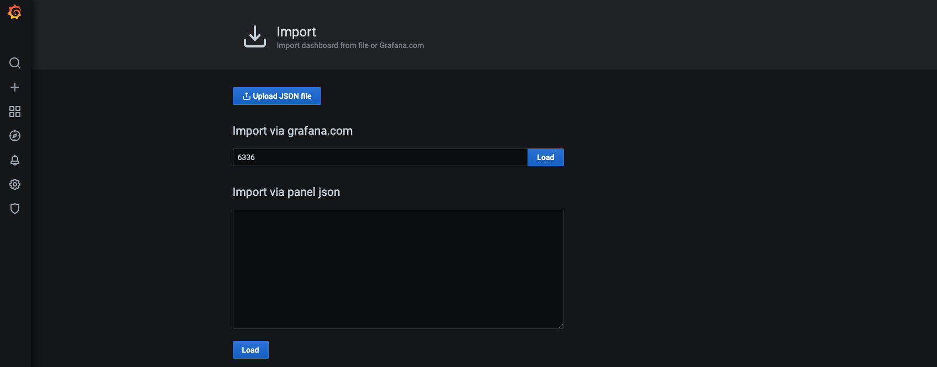



You then select the data source (we are using Prometheus):

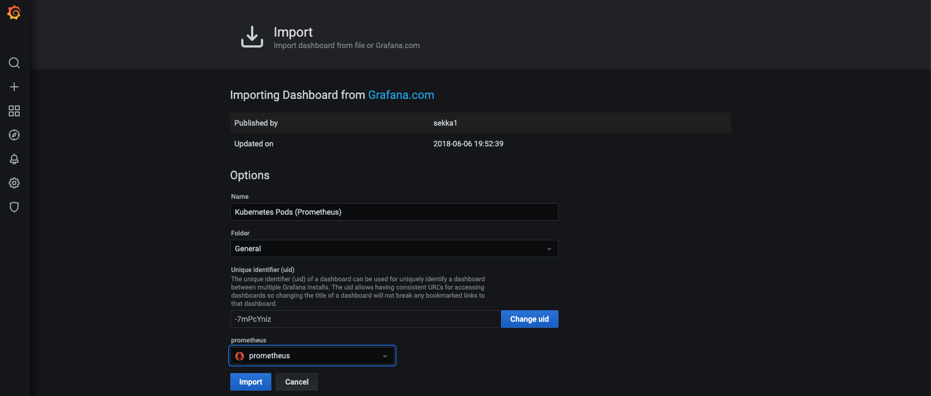



Type in the namespace “monitoring” at the top and hit return:

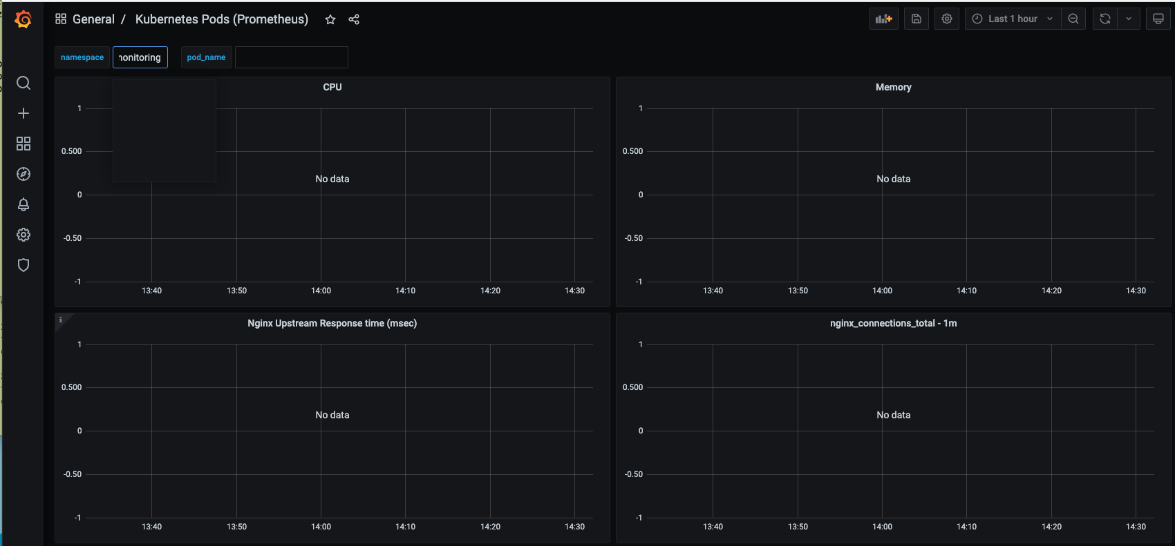



If you scroll down, you should see data similar to:

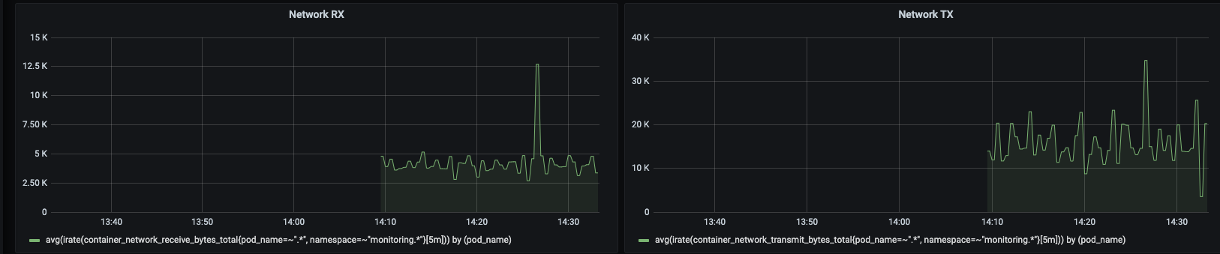

Also try to import dashboard 6417 for Kubernetes clusters:

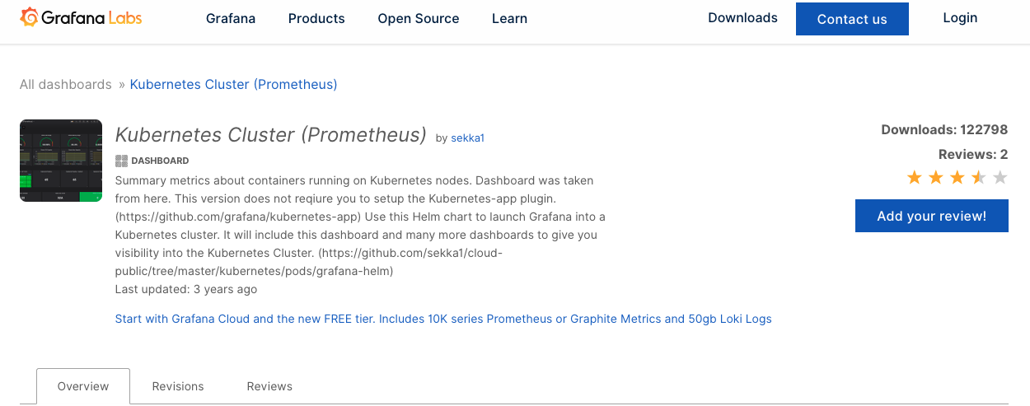

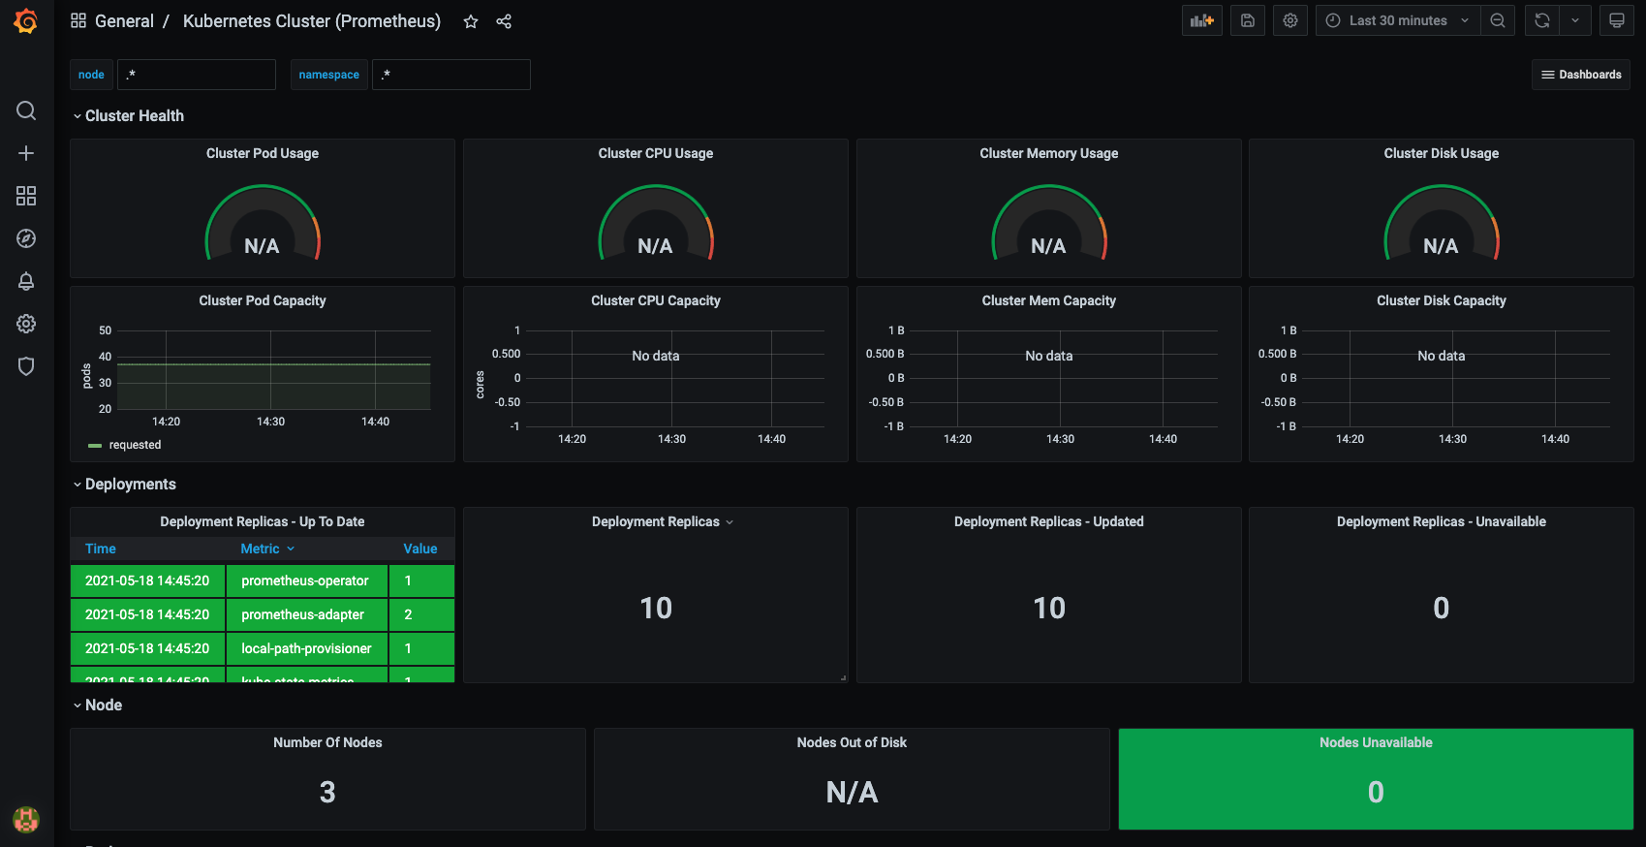



Note the “star” at the top for your dashboard

You can get other official and community dashboards here:

* https://grafana.com/grafana/dashboards

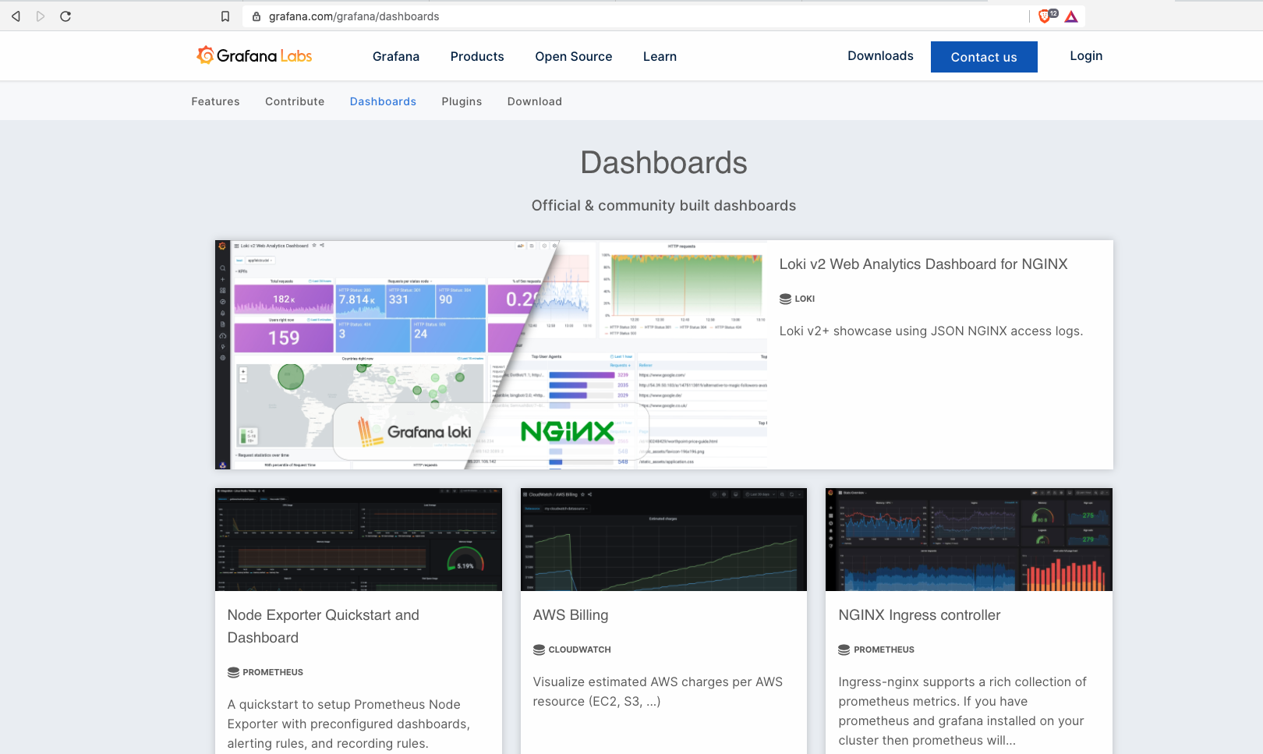

Back over in octant, take a look at “Applications” to see the workloads and resources running:

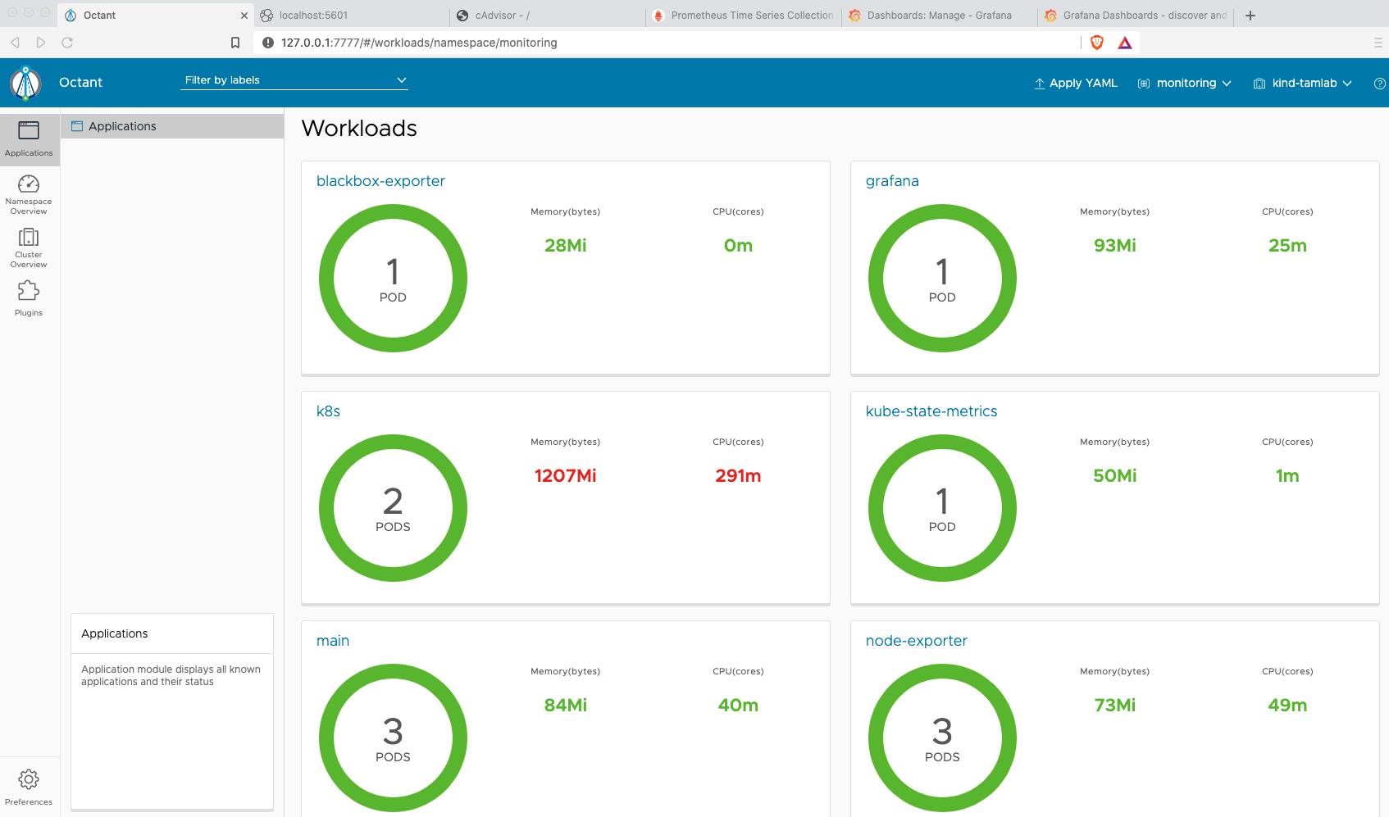

Now that we got it running using yaml files, let’s show you how easy it is to deploy using helm.

Follow the instructions on this website to use helm (skip the minikube commands since we are using KIND)

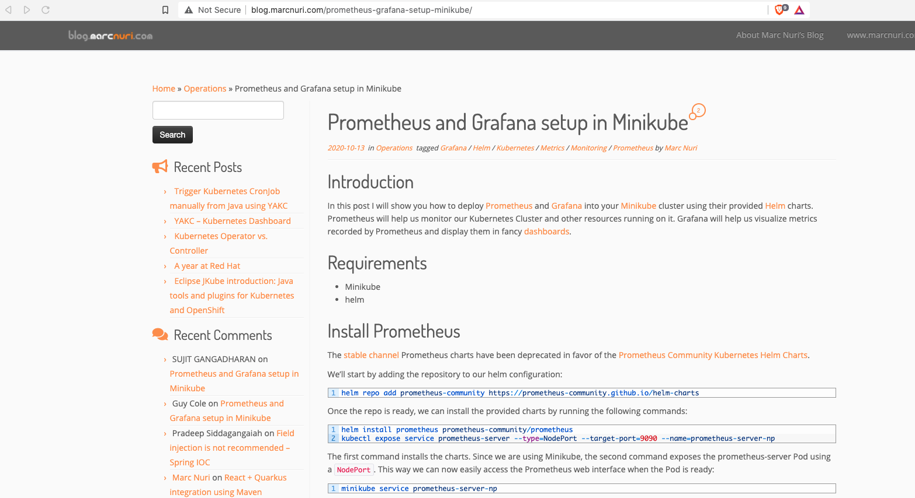

**Clean up old clusters**

Delete tamlab cluster if it exists

% kind delete cluster --name tamlab